**Types of Panels**

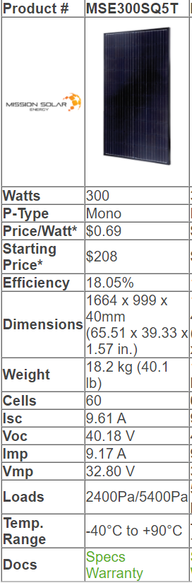Mission Solar MSE300SQ5T: $208/panel

Canadian Solar Superpower CS6K-300MS 300W Mono Solar Panel: $190/panel

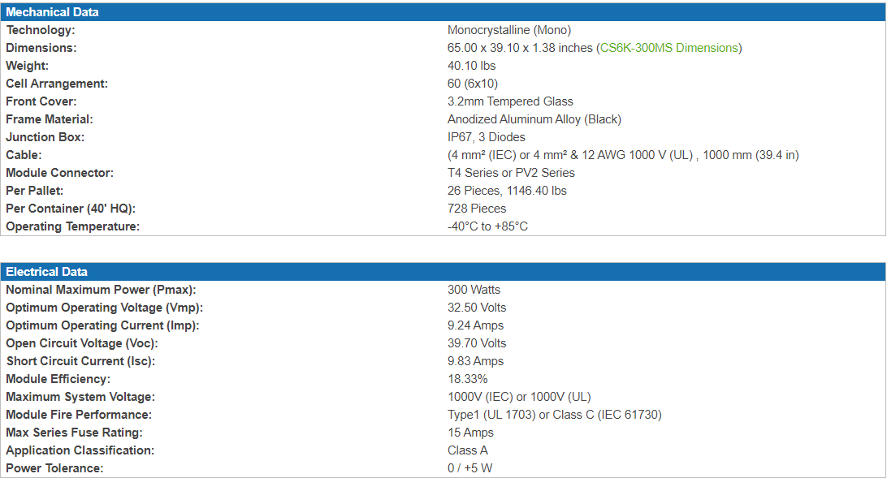

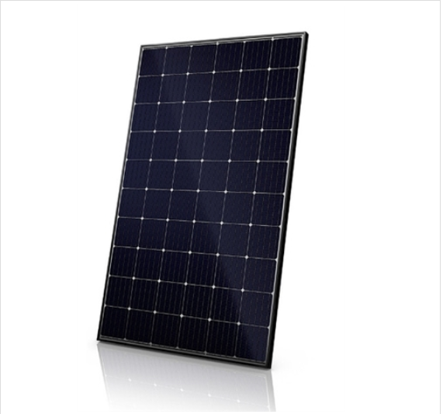

Panasonic 340 Watt Hit High Efficiency Solar Panel: $318/panel

